Please see below the cable fitting guide for a Chandler Barber Chair.

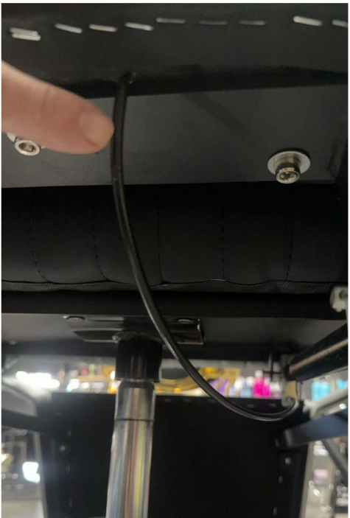
When the chair arrives the backrest will not be attached to the chair.
To fit this, remove the bolts from the bottom of the chair back, sit the back in place and reattach the bolts. Start them all first before tightening them completely.
You will notice a cable coming from the backrest, this cable operates the recline mechanism for the chair and needs to be connected under the chair.
If there is only small amount of cable showing, gently pull it out further out so it can easily reach the bracket. Please see the image to right.

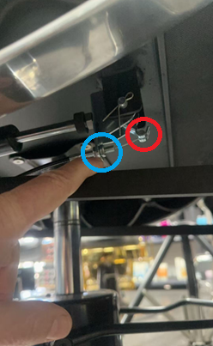
Once the backrest is secured into place and the bolts have been tightened, extend the cable to the bracket shown on the right.
On the very end of the cable there is a small metal cylinder, this goes between the slit in the silver lever which is circled in red.
When secure, loosen the nut on the end of the cable to the right in the blue circle.
Pull back on the cable and insert the threaded section through the bracket in the blue circle.
Tighten the not on the left side of the bracket until the slack is out of the cable. Note, if the lever in the red circle starts to move back, this is enough tension on the nut.
Replace the nut on the right to the threaded section that is on the cable.
Tighten the nut (hand tight is fine or you can use a spanner gently if you wish.
Test and mechanism by turning the levers on the side of the backrest and putting pressure on the top of the back rest.
If the backrest moves back without moving the handle on the backrest, the cable is too tight.
If the backrest is difficult to move back and forward with the lever moved, the cable is too loose.
When moving the handle, once it gets to its stop point, trying to turn it more will not make the backrest move easier, all this will do is damage the mechanism. This does not require a lot of force.

